**JOB APPLICATION TRACKING SYSTEM**

**INTRODUCTION:**

**1.overview**

Create a CRM Application which helps the application to track the No. of

jobs he applied and helps him to find the job posted by the various recruiters, find the best

attributes to be involved to run the process in a smooth way and easily to track.

**2.purpose**

Are you new salesforce ? Not sure exactly what it is , or how to use it?

Don’t know where are you should start on your learning journey? You’ve answered yes to any

of these question, then you’re in the right place. This module is for you.

**PROBLEM DEFINITION &DESIGN THINKING:**

Empathy map 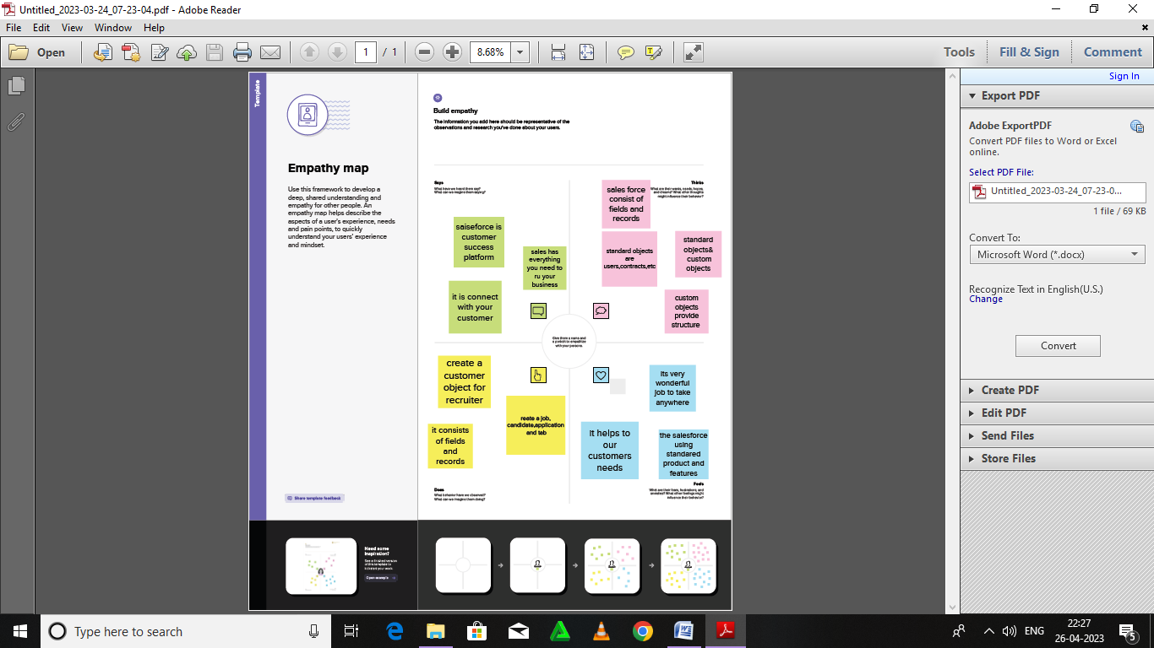

IDEATION & BRAIN STROMING MAP:

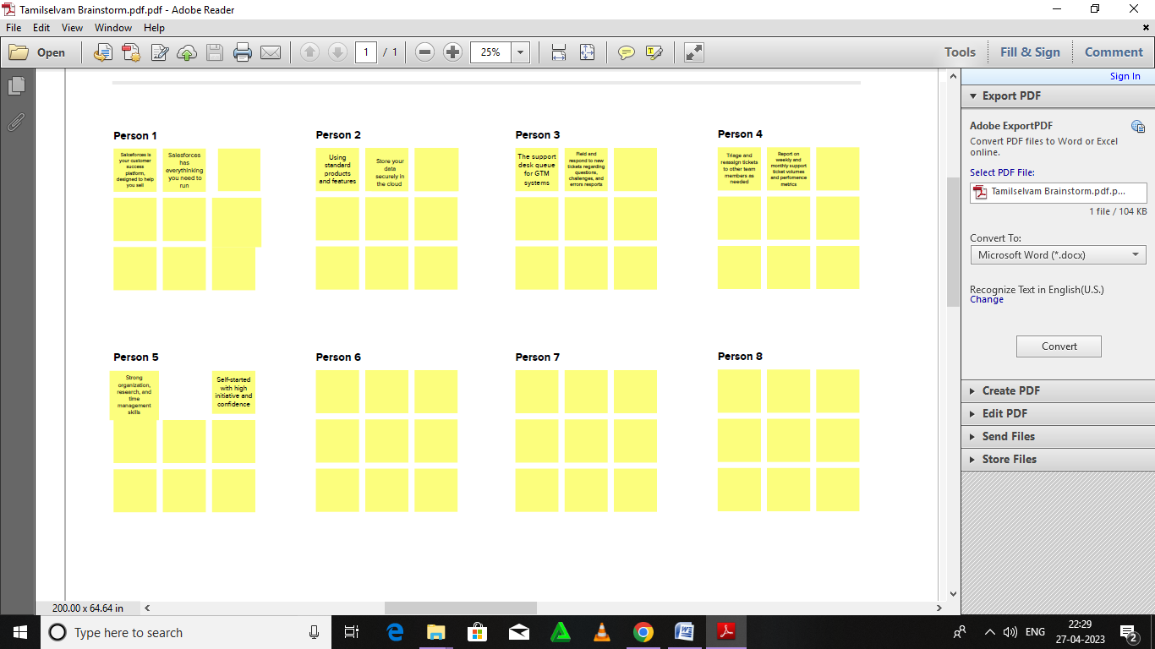

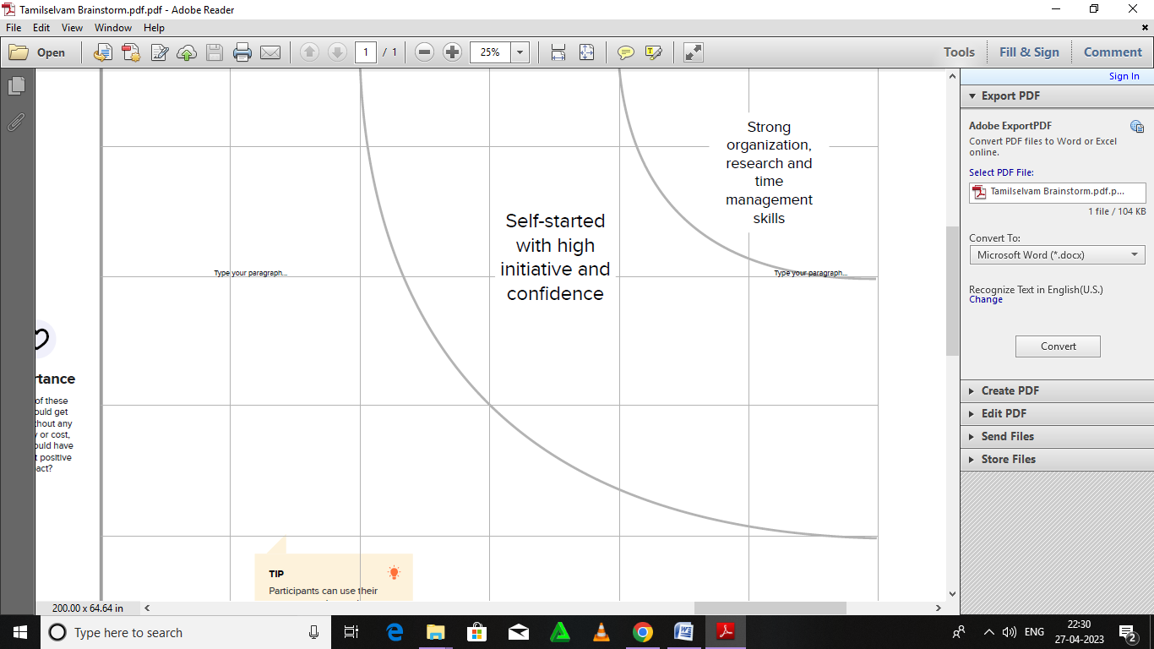

**RESULT :**

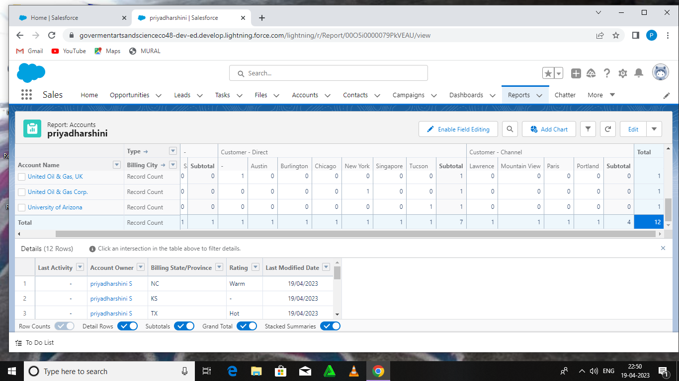

**ADVANTAGES :**

Applicant tracking system advantages include enabling you

focus more on tasks that truly require your attention rather than spending manual resources on

routine, mundane tasks. Good ATS can save almost 50% of your time by automating these

routine tasks. In doing so, your process get more efficient and faster.

**DISADVANTAGES:**

A disadvantages of ATS is missing qualified applicants due to

wrong keywords. Automatic eliminationof resumes that software cannot recognize and

interpret is another drawback of ATS. An applicant tracking system disadvantagesis that they

are open to manipulation.

**APPLICATIONS:**

* Streamlines recruiting
* Posts jobs on multiple job boards
* Saves time by automating mundane tasks
* Builds your brand
* Manages talent database
* Promotes easy collaboration among the recruiting teams
* Greenhouse
* IBM kenexa Brassring
* ICIMS
* Jobvite
* Oracle Taleo
* Smart recruiters

**CONCLUSION:**

Applicant tracking system for recruiters is very effective hiring solution that

most of the successful recruiters utilize. Because without it, there is a good chance that your

process of moving applicants through different stages can become very difficult.

**FUTURE SCOPE:**

An ATS creates opportunities to automate manual process,

increasing visibility into the hiring cycle for the entire recruiting team, and increase

opportunities for communication throughout the candidate journey. 78% of recruiters using

ATS report that it has improved the quality of the candidates they hire.

**APPENDIX:**

Source code

